**GRANARD MUNICIPAL DISTRICT**

Corporate Affairs,

Aras an Chontae,

**LONGFOIRT.**

**18th March 2015.**

**To: Each Member of Granard Municipal District.**

**Dear Member,**

You are requested to attend Meeting of Granard Municipal District to be held in the **Granard Community Library on Tuesday, 24th March 2015 at 4.00 p.m.** to transact business, as set out on the Agenda hereunder.

**Yours sincerely**,

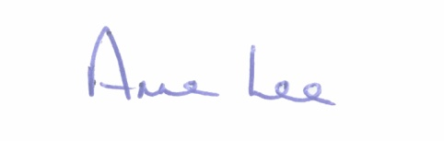

_______________

**Anne Lee,**

**Meetings Administrator.**

**AGENDA**

Prayer before meeting.

**1.** Confirmation of Minutes of Meeting of Granard Municipal District held on the 27th January 2015 - copy enclosed.

**2.** Matters arising from Minutes.

**3.** Consideration andapproval of Schedule of Granard Municipal District Works – report enclosed.

**4.** Jet Sking on Loch Gowna - Correspondence received from Cavan County

Council attached.

**5.** Notices of Motions submitted by Councillors, as listed hereunder -

Councillor P.J. Reilly.

“That a well to be bored at Dring Car Park for water to be supplied to the public toilets and also works to be carried out on the style on St. Patrick’s Shore, Loch Gowna for the forthcoming national swimming classes.”

“I request an update regarding the banning of Jet Skis on Loch Gowna.”

“I request that a letter be sent to Ms. Heather Humphreys, T.D., Minister for Arts, Heritage and the Gaeltacht, to increase the allocation of funding towards the purchase of the Motte in Granard.”

Councillor John Duffy.

“That Longford County Council applies for a low cost safety scheme for work on Smear Cross junction  on Arvagh/Aughnacliffe Road to move the Marion Grotto back to create sufficient space to allow heavy traffic to turn onto the Moyne Road in a safe manner.

“Could I have an update on progress on the motion passed for a safety scheme on the R198 adjacent to Moyne schools.”

Councillor Michael Carrigy.

“I call on the Granard Municipal District to support financially the local groups in Killoe, Mullinaghta and Lisryan with their plans to develop playgrounds in their communities.”

“I call on Longford County Council to support the Clonfin Commemoration Committee with their work programme in preparation for 1916.”

6**. Correspondence.**

1. Correspondence from Ms. Imelda Branigan, County Registrar, regarding Bunlahy National School Polling Station.

– copy attached.

**7.** A.O.B.